|  |  |  |  |  |
| --- | --- | --- | --- | --- |
| Sort Type | Data Set Size | Random (Time) | Descending (Time) | Ascending (Time) |
| Bubble Sort | 40 | 31.33 | 40.33 | 1.0 |
| Bubble Sort | 400 | 235.33 | 215.33 | 9.33 |
| Bubble Sort | 4000 | 12,648.0 | 7485.67 | 94.33 |
| Bubble Sort | 40,000 | 2,152,560.33 | 741,135.33 | 323.67 |
| Selection Sort | 40 | 16.0 | 17.0 | 15.67 |
| Selection Sort | 400 | 238.0 | 216.0 | 243.67 |
| Selection Sort | 4000 | 4877.0 | 4597.33 | 1424.0 |
| Selection Sort | 40,000 | 362,900.33 | 417,760.67 | 120,203.0 |
| Insertion Sort | 40 | 19.67 | 33.0 | 1.3 |
| Insertion Sort | 400 | 553.34 | 216.3 | 13.3 |
| Insertion Sort | 4000 | 3298.0 | 5254.33 | 108.67 |
| Insertion Sort | 40,000 | 223,303.0 | 446,030.0 | 419.67 |

* Ascending would be the best case: This shows the efficiency of the program to identify that no swaps need to take place and move on.



* Descending would be the worst case: This shows the efficiency of the program to swap every single element around.
* Random would be the general use case of unsorted lists. This shows the efficiency of the program overall in a real-life use case.
* Overall, the lower the times, the better.

Bubble Sort is O(n^2), in time complexity on average, Insertion Sort is O(n^2), in time complexity and Insertion Sort is O(n^2) in time complexity on average as well. All three (n^2) is calculated by virtue of having two for loops in each other which means that for each element it will loop through the entire list of items.

The Bubble Sort seems to be the best to be used in situations where no swaps need to take place (Almost Ascending Sorted datasets), while the Selection Sort seems to be best used in cases where almost all the data is ordered in Descending as it seems to be able to swap items faster. Overall, the Insertion Sort seems to have a good compromise in speed when it comes to sorting larger random datasets. Scoring lower speeds in comparison to both the Selection Sort and Bubble Sort in the 4000 and 40,000 sample sizes.

Bubble Sort

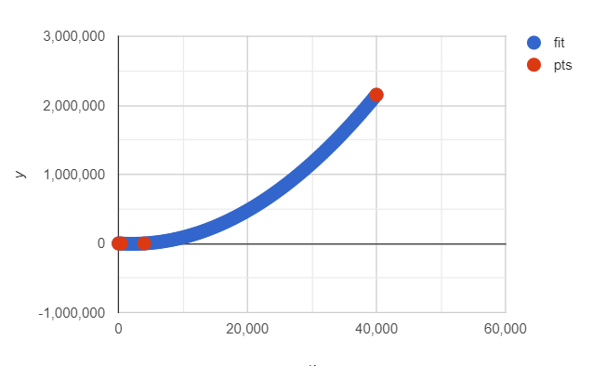

Selection Sort

Insertion Sort

Where y is the time taken and x is the dataset size for random datasets. As you can see Insertion Sort has a lower time in comparison both the Selection and Bubble Sort at larger datasets.